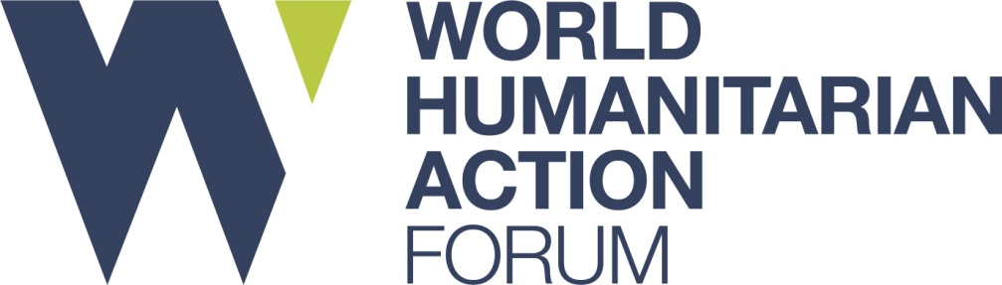

WHAF 15-16th October 2019
On behalf of The Humanitarian Forum, our host partner Türk Kızılay and over 50 partners, we are pleased to welcome you to the World Humanitarian Action Forum 2019, taking place in Istanbul.

We hope that you will find the following information helpful for your visit.

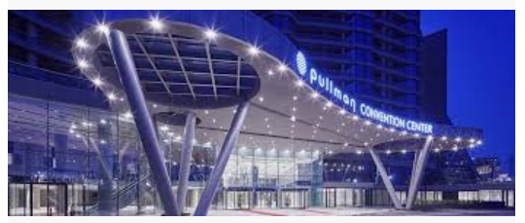
Venue:
Pullman Hotel and Convention Centre, Istanbul – Turkey.

ADDRESS: YENİBOSNA MERKEZ, 1. ASENA SK NO:15, 34295 BAHÇELİEVLER/İSTANBUL: http://www.pullmanistanbul.com/en/index.php
Telephone: 00 90 212 411 10 00 E-mail: info@pullmanistanbul.com

Hotel recommendations:
The following two hotels are situated in the same building as the Forum venue and so we highly recommend delegates to book at one of these hotels.

We have been informed that these hotels will provided a reduced rate for NGO’s participating in the Forum. Please use conference promotional code ‘Turk Kizilay’ when making the booking. This will be at the discretion of the hotel at the time of the booking.
Please note that the Pullman and Mercure Hotels are in the same building as the conference venue.

- Pullman Istanbul Hotel and Convention Centre
- Mercure Istanbul West Hotel and Convention Centre
- Clarion Hotel Golden Horn İstanbul/Avrupa
- Hilton Garden Inn Istanbul/Europe

Travel
Istanbul Sabiha Gökçen Airport is the closest airport to the venue. However Istanbul Airport is the main international airport.

You can get a taxi from outside the airport and it should take about 45 minutes to arrive at the Forum venue.
Kindly check with your hotel bookings if they offer a free shuttle service as this can be arranged prior to travel.
The two hotels recommended above provide a free shuttle service from Istanbul Airport leaving at 0900, 20.00 and 22.00. Please check website and arrange with hotel:
http://www.pullmanistanbul.com/en/shuttel.php
https://www.accorhotels.com/gb/hotel-9428-mercure-istanbul-west-hotel-convention-center/index.shtml#section-description

VISA ARRANGEMENTS
Kindly note your passport must be valid for more than 6 months at the time of your arrival.
- Obtaining a visa at a Turkish Embassy:
  - For participants wishing to apply for a visa at the Embassy Turkey in their country of residence, we kindly ask you to contact us and we can issue a supplimentary document that can help facilitate your application.

- Obtaining an Online E-visa:
  - For participants wishing to obtain an E-visa, you are required to fill out the online visa application form at https://www.evisa.gov.tr/en/.

Should you have any queries, please contact Ms Busra Kara at busra.kara@kizilay.org.tr or call +90 312 203 4700/Ext 4936

Please be sure to apply for a visa at least 1 week before the expected date of entry into Turkey.

Emergency Focal Point for the Forum
Mr. Melih OZLER - melih@bekamedya.com.tr / +90 539 855 2878

Getting Around:
Public Transport:
Istanbul has good transport links that allow easy travel options to use for tourists, all common routes are facilitated by by Trams, Metro and Buses. Fares for all three can either paid by purchasing a token from a sales booth at the station or via an Istanbul Card, which you top up with credit and use on yor travels.

Language:
Turkish is the official language in the country. English is not commonly spoken among the local community however very frequently spoken at tourist locations and at hotels.

Currency:
The Turkish Lira is the currency of Turkey.

Electricity:
Turkey operates on 220 volts, 50 Hz, with round-prong European-style plugs that fit into recessed wall sockets /points.

EMERGENCY SERVICES IN ISTANBUL
- Police emergency: 155
- Medical emergency: 112
- Fire emergency: 110
- Fire emergency: 177 (Woodland/Forest fire service)
- Maritime emergency (Coastguard): 158
- Missing child/Women's helpline: 183
- Tourist Police: 0212 5274503 (Istanbul only)

Background information

About WHAF
The World Humanitarian Action Forum (WHAF) is an initiative, organised by several humanitarian, development and peace-building organisations, that aims to encourage dialogue and action through collaboration and partnership working. This event is open to all that share a passion for making a difference and believe in being part of effective humanitarian work that better serves beneficiaries. It is a continuation of the successful WHAF 2017, which was held as a pilot project to ascertain the need for enhanced collaboration between different humanitarian actors on key issues affecting the sector.

The WHAF 2017 Forum drew over 230 delegates, including 97 international delegates representing 77 organisations from the global ‘South’. For NGOs, there is a clear recognition of the need to better connect with other responses through operational partnerships. Building a broader support base through engagement with more diverse stakeholders is essential to strengthen the acceptance, perception and relevance of humanitarian aid.

WHAF aims to enhance partnership and coordination amongst humanitarian actors and provide an opportunity for participants to share effective humanitarian practices and responses, tackling pertinent issues especially those affecting local and national NGOs from the global ‘South’.

WHAF’s key objectives are:
• To develop strategies for informing policy on key issues affecting humanitarian organisations particularly those from the global ‘south’.
- To develop joint initiatives and campaigns for collaborative working at local, national and international levels

WHAF provides added value by being:
• Managed by partners: The initiative is led by an Advisory Group consisting of several key partners. Steering groups set up for each roundtable develop the key issues affecting the sector and plan the roundtables.
• Action orientated: WHAF facilitates discussion around what needs to be done to improve efficiency in humanitarian work. These recommendations are then translated into campaigns and initiatives.
• A collaborative approach: WHAF partners to agree on joint campaigns and issues to address throughout the year thus, facilitating improved collaboration in humanitarian work.

What to expect?
Over the course of the two days, you will have the opportunity to be part of roundtable working groups to discuss key issues affecting the sector. It will also be a chance to learn from each other, share experiences and to form lasting bonds with other participants. WHAF is passionate about creating an initiative to better coordinate humanitarian work and address common issues affecting the sector. Now, more than ever before we believe a collective agreement is required on regional priorities and mechanisms for organising humanitarian responses that promote long-term thinking and restoring human dignity.

Structured Networking and Partnership Sessions:
At WHAF we would like to provide opportunities for more people and organisations to share their stories and ideas. In addition to the informal networking that will happen during breaks, lunch and in between, we would like to enable more partnership building and collaboration. To help facilitate this further you will have access to the event app which will allow you to connect with others and structured networking sessions to enable further collaboration. The structured networking sessions, are going to be organized in a world café style to further enable partners to build relationships, develop new contacts and share effective humanitarian practices and coordinate with other leading humanitarian actors and specialists across the globe.
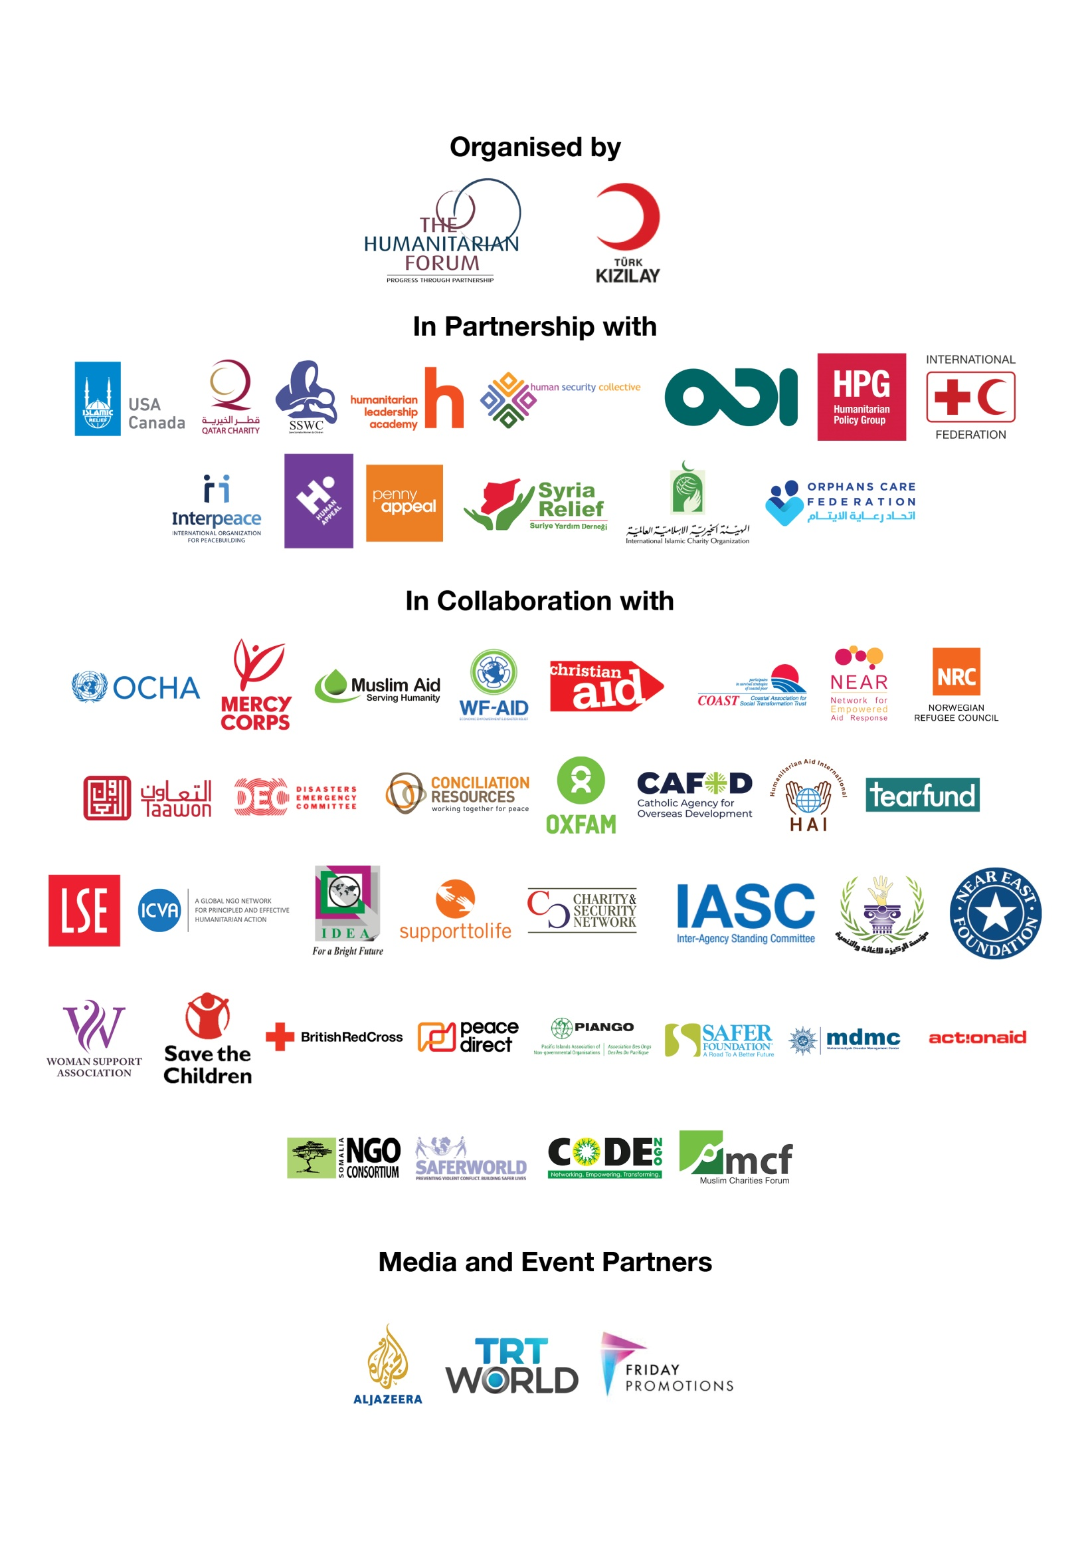

Partnership working
WHAF Secretariat

The Humanitarian Forum

37 Westminster Bridge Road,
6 Whitehorse Mews,
London, SE1 7QD,
United Kingdom

Email: whaf@humanitarianforum.org
Website: www.whaf.org.uk
Tel: +44 (0) 203 096 1787

