

Zakat Insights: a Newsletter on Zakat and Justice
#3: April 2026
Welcome to Zakat Insights, sharing the latest news, stories and developments on the
subject of Zakat.

Earth Day, Khala’iqiyya and Zakat

April has marked a month of environmentalism. Earth Day took place on the 22nd of April, followed at the end of the month by the First Conference on transitioning away from Fossil Fuels, in Colombia. The conference, coined “minilateralism” is considered an effort to seek solutions on the fossil fuel transition, where UN-led instruments have failed to do so.
The climate crisis as a human crisis is infrequently contested, and in recent years a discussion has emerged that seeks to explicitly link humanitarianism and environmentalism, to acknowledge their interdependence in practice, referred to as eco-humanitarianism or eco-humanism.
It is also a concept that Muslim-charity thought leadership has been pioneering for decades, albeit, it goes by a different name: Khala’iqiyya (pronounced Khah-la-ee-qeey-yah) which has been translated to English as Creaturitarianism.
In 2008, during his final year as the director of Islamic Relief, Dr.Hany El Banna (WHAF founder) wrote about how humanitarianism ignored the rights of the rest of creation that is “ created by God to serve us and share this mortal life with us.” Explaining: “This human-centred approach has produced an individualistic system driven by self-interest, moving away from moral and ethical principles…forgetting—or even excluding—the interests of other creatures.
El-Banna´s vision promotes the replacement of humanitarianism with Khala’iqiyya (Creaturitarianism): “to establish a foundation of active, positive, interdependent, and comprehensive partnership with all creatures.”
And on the connection to Zakat?
Zakat, scholars have explained, sits within an Islamic moral economy that provides a framework of concepts and principles relating to the environment and the responsibility of humanity. These concepts include, but are not limited to: Tawhid (Divine Unity); Khilafa (Stewardship), Al Mizan (Balance); and Khala’iqiyya (Creaturitarianism), that together discourage excess, promote sustainability, redistribution and care for creation.
A number of individuals and groups have considered that Zakat, an instrument that seeks to restore economic and social balance and access to resources, could be strategically applied to further principles of Khilafa and Al-Mizan with the environment as well. BAZNAS, BSI, and UNDP launch of the Green Zakat Framework in 2025 is one example of such an approach. Aprils Zakat learning group, detailed below, further explored these themes.

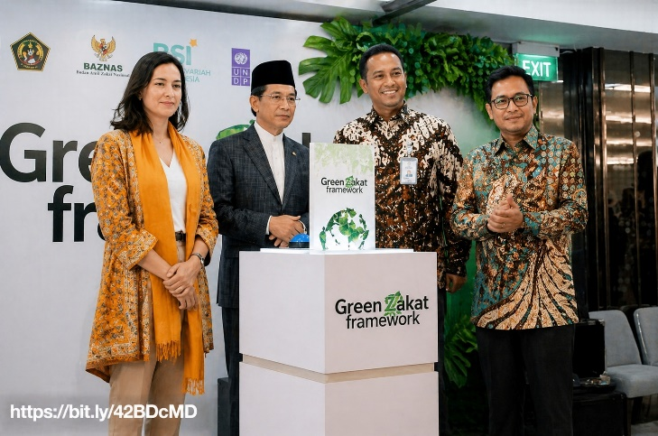

News in Brief, Stories and Developments

Global: IOM and INGO Muslim Hands sign MOU to establish a framework of cooperation for the distribution of Zakat and Sadaqah for humanitarian assistance.
Maldives: Zakat House reports record Zakat al-Fitr Ramadan donations, credited to “a multi-channel collection strategy” that integrates digital payment.
Malaysia: RM230 Zakat fraud case involving NGO dominates Zakat headlines.
UK: Muslim Council of Britain´s Wajid Akhter calls for Zakat collected in the UK to be directed towards domestic priorities such as housing, knife crime and the economy.
Nigeria: The Sokoto State Zakat and Waqf ( Endowment) Agency SOZEA collect sheep as Zakat from NEXUS FARMS in a gesture aimed at supporting charitable causes in the state.
Bangladesh: Op-ed by Prof. M. Kabir, Ph. D. calling for a strategic approach to Bangladesh´s voluntary Zakat practices: “Provided it is well-organized, open, and has a clear strategic vision, Zakat has the potential to be an effective instrument for creating a more compassionate and equitable society.”
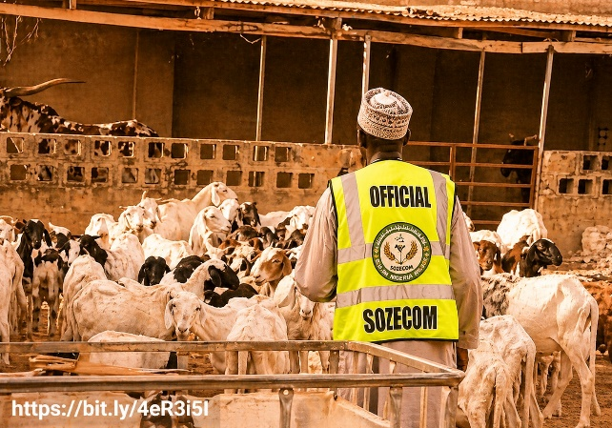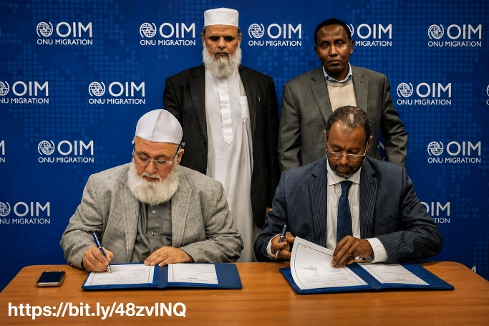

Reflections from Dr Hany El-Banna
Reflections from Dr Hany El-Banna 📍 Istanbul, 26-28.04.2026

The Muslim Impact Forum 2026, a three-day global forum convening leaders from politics, charity, and business, brought together a diverse international audience to move from observation to action and work to shape the future, including key discussions on Zakat.
There was a strong emphasis on the need to promote leadership from within communities, particularly in times of crisis. Conversations on Zakat revealed different opinions. Some explored and supported the growing role of UN agencies in Zakat-related humanitarian efforts, while others stressed that Zakat, as a pillar of Islam, should remain community-rooted and not be reduced to a financial instrument used to fill institutional funding gaps.
Reflections also revisited the evolution of Islamic social finance, including its emergence around the World Humanitarian Summit process in 2015. Questions were raised about whether framing it as “faith-based finance” risks weakening its unique ethical and institutional foundations.
The concept of the “soft powers” of Zakat, or better understood here as faith community building, highlighting its ability not only to redistribute wealth, but to strengthen relationships, shape shared values, and define accountability between giver, institution, and the right holders.
Overall, discussions in the Forum highlighted both the potential and responsibility of Zakat: to remain principled, community-rooted, and responsive to contemporary challenges. Strengthening its governance and ensuring more inclusive administration will be key as these conversations evolve.

Learning Group: Zakat and Environmental Justice, 24.04.2026

During April´s co-learning group, part of WHAF´s series on Zakat and Justice, participants discussed and debated the utilisation of Zakat for environmental and climate justice objectives. Some participants felt that the broadening of Zakat´s scope was a “slippery slope” that compromised its primary focus – poverty alleviation. Others felt that there were categories that provided space for broadening without compromising the focus; for example, fi sabilillah, which it was argued permits adaptation to current needs and could provide a space to extend care to creation. Others felt that, rather than fi sabilillah, the opportunity to accommodate the environment in Zakat lies within fuqarah and masakeen, through “wakalah,” whereby the rights holders’ agency is maintained and they give the organisation permission to act on their behalf.
The connection between environmental justice and poverty justice was established by participants who noted that the poor are the ones most affected by climate change. There was a debate on root causes, where some participants considered Zakat capable of addressing them, whereas others argued that is the role of Waqf and Sadaqah. Others agreed that Zakat cannot solve everything alone and needs to be considered alongside the role of other Islamic instruments.
The concept of Al-Mizan was discussed as relating to both balance between human needs and planetary limits with socio-economic balance, between rich and poor and Khala’iqiyya or Creaturitarianism was related to the responsibility of humanity to establish this care and balance. “Productive” Zakat and “Transformative” Zakat were offered as conceptual frameworks to accommodate environmentally oriented Zakat programming.
Examples were provided that sought a way to balance the different perspectives, such as ensuring that projects directly benefit eligible recipients whilst offering indirect community and environmental impacts that they have consented to. The example of edible forests was raised to illustrate this, balancing environmental protection (maintaining soil integrity and preventing erosion) with the provision of sustainable livelihoods for eligible recipients. There was a general consensus that considering nuance, clearly defining concepts and considering the different lenses being applied, facilitated the pursuit of mutual understanding.
Participants further discussed what has now become a recurrent theme, the need for standardisation and leadership for the international administration of Zakat. It was explained that authoritative leadership on permitting Zakat for environmental programming, gave these initiatives legitimacy and ensured accountability, whereas splintered and un-authorised “colourful” initiatives were problematic. One participant made the point, that different approaches and perspectives are inevitable and need to be accommodated, explaining that people in countries experiencing high levels of poverty and climate change impacts are likely to view the debate on approach differently, perhaps less rigidly, to people who do not share this lived experience.
Proposals for creating a global standard, certification process and zakat funds (both centralised and localised were discussed) were raised alongside which entities and instruments exist that provide examples or opportunities. Alongside these proposals, participants pointed out Zakat´s “soft power” (spiritual or faith community strengthening) objectives, the need for standardisation not to overlook these aspects, and the need for NGO introspection– problematising how NGOs competitivity and absorption within the Western model of aid, has sometimes led to the forfeiting of Islamic ethics.

NEXT UP
Beyond financing: Zakat for faith AND Zakat and aid reforms initiatives. 04.06.2026

Register here join our coming co-learning session

Contribute to an upcoming anthology

Using earlier written works, WHAF are compiling an anthology of reflections on the topic of Islamic humanitarianism. We are looking for short excerpts from already published pieces that offer poignant contributions on a wide range of concepts and principles that relate to Islamic humanitarianism (for example and not limited to: adl, mizan, rahma, karama, ihsan, al-karim) - and their significance in relation to humanitarianism today. If you would like your work to be considered for inclusion, or would like to recommend a publication, we look forward to hearing from you.

Have anything to share or contribute on Zakat and Justice? Get in touch!






